Support for GeneCards

Overview

“GeneCards® is a searchable, integrated database of human genes that provides concise genomic, proteomic, transcriptomic, genetic and functional information on all known and predicted human genes. Information featured in GeneCards includes orthologies, disease relationships, mutations and SNPs, gene expression, gene function, pathways, protein-protein interactions, related drugs & compounds and direct links to cutting edge research reagents and tools such as antibodies, recombinant proteins, clones, expression assays and RNAi reagents.” http://www.genecards.org/
GeneCards was developed by scientists at the Crown Human Genomics Center and the Bioinformatics Unit of the Weizmann Institute of Science in Rehovot, Israel (the "WIS").
“The rights in and to GeneCards (excluding information contained therein obtained from third parties), vest in Yeda Research and Development Company Ltd., the commercial arm of the WIS ("YEDA"). If you are a commercial entity, in order to access and use GeneCards, you will need to enter into a license agreement with Xennex, Inc. ("Xennex"), which has been granted the exclusive right by Yeda to license the access to and use of GeneCards to commercial end-users worldwide and you will need to pay the applicable fees for such license.”
The GeneCards service is provided free to academic non-profit institutions but is subject to the following terms:
- Subject to the terms and conditions of these ToU, YEDA grants Academic User a non-exclusive, non-transferable and non-sublicenseable licence to access and use GeneCards via the World Wide Web only, through the http://genecards.org/index.shtml website (the "Website") or any of its academic mirrors listed in http://genecards.org/mirror.shtml (the "Service"). No license is granted hereunder to any enhancement or update of or to the Service.
- Academic User may not sell, lease, rent, sublicense, assign, export or transfer in any other manner the Service or the rights of access to or use thereof, or any underlying information, software or other technology, and/or any documents, CDs or any other tangible media representing, embodying or containing any of the foregoing or portion thereof, to any person or entity.
- The Service is provided free of charge to academic non-profit institutions.
- Neither the WIS nor YEDA shall provide (or be obligated to provide) Academic User with any support relating to the use of the Service, except for online documentation contained in the Service.
- Academic User acknowledges and agrees that the Service, including, without limitation, text, data, compilation, software, sound, photographs, video, graphics or other material contained in or presented to Academic User as part of the Service and the arrangement thereof, and any YEDA software used in connection with the Service, contain proprietary and confidential information that is protected by applicable intellectual property and other laws. Academic User shall not copy, reproduce, distribute or create derivative works of or otherwise modify the Service or any part thereof.
- Academic User agrees not to reverse engineer, recompile, disassemble, copy or otherwise attempt to discern the source code of any component of the Service. YEDA reserves the right to terminate any CPU intensive processes. Academic User may not mount an attack against the Service, attempt to gain root access, or conduct any other activity intended to disrupt the Service.
- These ToU shall be governed by and construed in accordance with the laws of the State of Israel, without regard to or application of choice of law rules or principles. Academic User hereby consents to the exclusive jurisdiction of the competent courts in Tel-Aviv-Jaffa, Israel.

Technical Approach
Due to licensing issues, we should proceed as follows:
- Identify third party open source databases leveraged by GeneCards and provide support for a select few of these data sources. caBIO currently provides access to some of these data sources. This will require an evaluation of each GeneCards data source to determine whether these data sources are open source.
- Consider using an approach similar to GeneCards for displaying search results (vertical vs. horizontal view)
For example, a search on EGRF (by symbol only) yields the following results:
- Aliases and Descriptions  - EntrezGene summary  - Uniprot/Swiss-Prot ID, Function, location information, and PDB structures  - Genomic View from UCSC GoldenPath including location information  - Post-translational modifications  - REFSEQ proteins  - ENSEMBL proteins  - Human Recombinant Proteins  - Gene Ontology  - Antibodies  - Assays  - InterPro domains/families  - ProtoNet protein and cluster  - Protein families  - RNAi  - Clones  - Primers  - siRNA  - Invitrogen and KEGG Pathways  - Protein Interactions  - Drugs and Compounds from BIOMOL  - Chemical Relationships from almaKnowledgeServer  - PharmGKB drug compound relationships  - Expression Data (ABI TaqMan)  - CGAP Sage Tags  - Orthologs/Paralogs  - NCBI SNPs  - OMIM Disorders  - Mutations from Genatlas, Humang Gene Mutation Database, Genetic Association Database, Humang Genome Epidemionlogy, Tumor Gene Database, Breast Cancer Gene Database  - Pubmed Atricles | 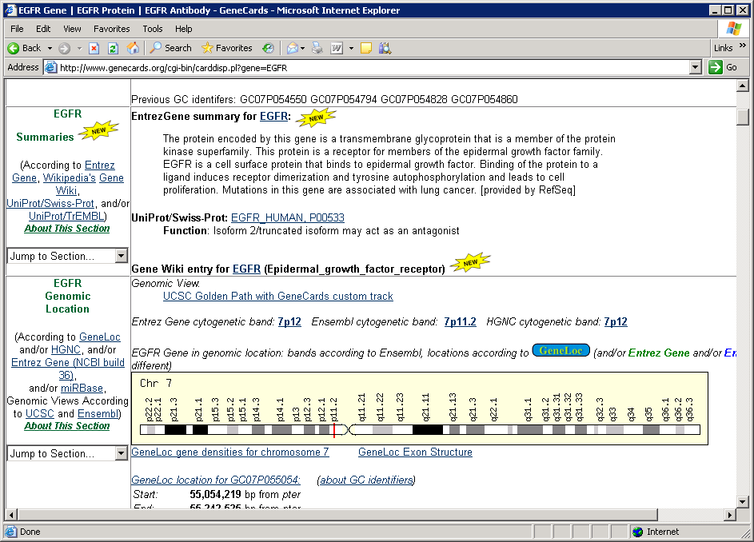  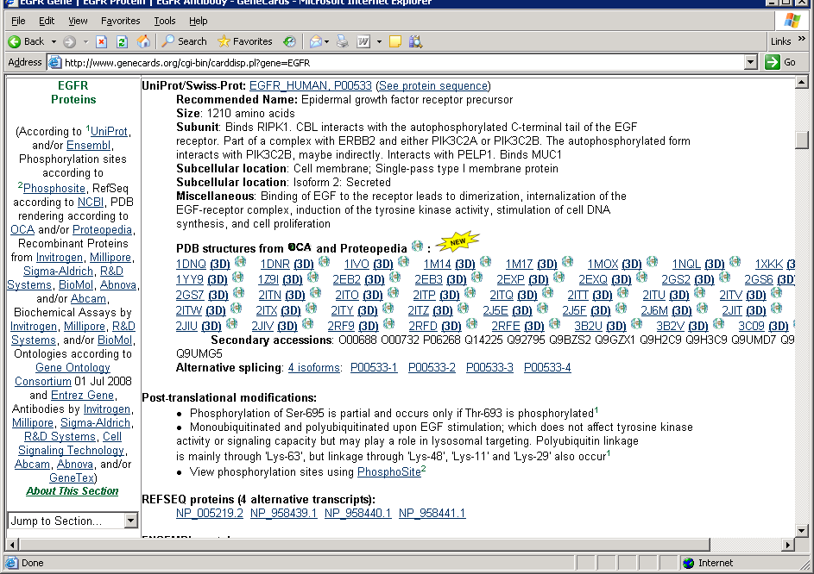  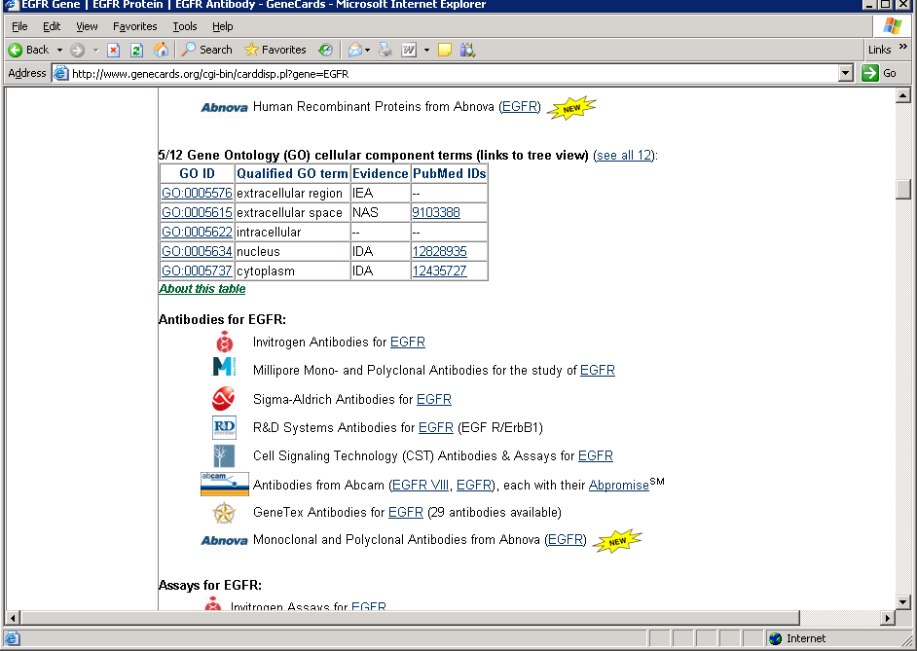

GeneCards data sources are identified in the table below and are available at: http://www.genecards.org/sources.shtml.
Data Source | Description | Status (Open, Commercial)
Abcam | maintains a catalog of antibodies, some are made internally, while others are sourced from institutes, academic laboratories and primary manufacturers. | Commercial
Abnova | offers a unique complete monoclonal antibody and protein experience for the customer that is different from traditional custom production companies and laboratories. | Commercial
AceView | offers an integrated view of the human and nematode genes as reconstructed by mRNA and EST alignments. | Open; Data Integrator Tool; Utility as a visualization tool
AKS | extracts knowledge from biological databases and text repositories, enabling users to uncover the knowledge hidden within these data sources. | Commercial
Alternative Splicing Database | (ASD) maintains a database of alternative splice events and the resultant isoform splice patterns of genes from human, and other model species. | Open; provides alternative. splice events , resulting transcripts and exons for human, mouse, rat  Listing of all genes together with sequence that resulted in at the very least one confirmed intron.  Listing of the reference transcript structures for the genes.  Listing of EST/mRNA's used in the confirmation of introns and exons.  Listing of the splice patterns and the confirming EST/mRNA's.  Lists the nucleotide sequences of the observed splice patterns.
Applied Biosystems | is a supplier of life science tools world-wide, including gene expression and genotyping assays and resequencing sets. | Commercial
ATLAS | of Genetics and Cytogenetics in Oncology and Haematology. | Open; Provides list of genes implicated in cancer along with putative cancer genes (Gene-Disease Associations); Information obtained by Literature survey.
BLOCKS | is a database of Blocks multiply aligned ungapped segments corresponding to the most highly conserved regions of proteins. | Open;  Tool that creates multiple alignments of domains in Interpro  No longer updated; Last release was in Apr 07 based on Interpro 14;
BioGPS | service from the Genomics Institute of Novartis Research Foundation which provides an integrated portal which displays gene-centric annotation, including "annotation" based on reference gene expression data sets. | Allows user to create customizable views by providing plugins that integrate data from different data sources
BIOMOL | a supplier of specialty biochemicals, with applications in signal transduction, lipid research, apoptosis, neuroscience and drug discovery. | Commercial
The Breast Cancer Gene Database | (BCGD) lists facts about genes implicated in breast cancer.
CGAP | (The Cancer Genome Anatomy Project) determines the gene expression profiles of normal, precancer, and cancer cells, leading eventually to improved detection, diagnosis, and treatment for the patient. | Open; Already in caBIO
CroW21 | Human Chromosome 21 Database at the Weizmann Institute of Science.
CST (Cell Signaling Technology) | provides discovery tools for cell signaling research, including information about pathways and phosphorylation sites. | Commercial
DiscoveRx | provides a family of assay solutions for GPCRs, Kinases, Protein Expression and Translocation, using its proprietary EFC chemiluminescent detection technology. | Commercial
Doctor's Guide to the Internet: | a Web service presenting news about biomedical research and its applications. GeneCards presents links and titles of interesting articles stored there.
DOTS(Database Of Transcribed Sequences | developed by the Computational Biology and Informatics Laboratory at the University of Pennsylvania. | Open; Analytical service that provides consensus transcript by clustering human and mouse genes/transcripts that are publicly available;
ECgene | a new EST clustering method that produces gene models based on genomic alignment of mRNA and ESTs. | Open; Analytic Tool for clustering ESTs; Requisite data (dbEST) already in caBIO
Ensembl | a software system producing and maintaining automatic annotation on eukaryotic genomes, which provides identification of known human genes in the genome sequence and prediction of additional genes with supporting evidence. | Open; Already supported in caBIO
EntrezGene | at NCBI provides a single query interface to curated sequence and descriptive information about genetic loci. | Open; Already supported in caBIO
euGenes | Genomic Information for Eukaryotic Organisms Database for more details on similar genes in other organisms. | Open; Already supported in caBIO  Compiles information such as symbol, name, genetic maps, GO, etc. for different organisms from various data sources.  Mouse data obtained from MTB ftp://ftp.informatics.jax.org/pub/informatics/reports/  Human data from locus link (already in caBIO)
EXPOLDB | a database of expression variation in blood leukocytes in monozygotic twins and unrelated individuals. | TBD
FlyBase | a database of the Drosophila genome | Open; Focuses exclusively on Drosophila
Genatlas | a catalog of genes, markers and phenotypes with many links to major data sources. GeneCards offers the short description of the gene that often contains interesting, concise information about its cellular functions and/or role in diseases. | Tool to search database of gene-disease association obtained by text mining;  Database not downloadable;  Disease information linked to OMIM  Database restricted to genes with known cytogenetic location;  Functionally similar to Cancer Gene Index
GenBank | the NIH genetic sequence database, an annotated collection of all publicly available DNA sequences. | Open, Already supported in caBIO
GeneAnnot | Annotation of high-density oligunocleotide arrays at the Weizmann Institute of Science, with links to Affymetrix probe-sets. | Open  Analytical tool that annotates probes from some Affymetrix microarrays, with Genbank, Ensembl and RefSeq ids by mapping probeset to transcripts and the transcripts to genes.
GeneLoc | (formerly The Unified DataBase (UDB)) integrates information on the human genome, with emphasis on mapping information. Mapped DNA segments, classified by categories (such as genes, EST clusters and STSs mapped by various methods) are presented on a Megabase-scale integrated map, with further links to relevant databases. | Open Source;  Presents an integrated map for each human chromosome, based on data integrated by the GeneLoc algorithm.  Includes links to GeneCards, NCBI's Human Genome Sequencing, UniGene, and mapping resources  GeneLoc algorithm creates an integrated map of the human genome. Unifies gene collections, eliminates redundancies, and assigns each gene a GeneCards ID. GeneLoc currently uses gene sets from NCBI and Ensembl. Compares these collections, to identify which should be consolidated and which are discrete. Effects this gene integration by comparing genomic locations. The resulting GeneLoc 'gene territory' reflects range of the unified genes. Additionally, DNA segments, classified by categories (such as STSs mapped by various methods and EST clusters) are presented, alongside the genes, on a Megabase-scale map, with further information and links to relevant databases.  GeneLoc includes data from numerous resources, including the Genome Database, Whitehead Institute/MIT Center for Genome Research, Genethon, NCBI and others (references).
GeneNote | the Gene Normal Tissue Expression database at the Weizmann Institute of Science | Not open source;  Database of expression profile of human genes in healthy tissues; Based on Weizmann Institute of Science DNA array experiments, (Affymetrix HG-U95)  Data:  Gene and tissue clustering based on expression profiles  A full genome ranking procedure according to the gene's tendency for tissue specificity, from tissue-specific to housekeeping genes.
GeneTests | (formerly GeneClinics): a clinical information resource relating genetic testing to the diagnosis, management, and genetic counseling of individuals and families with specific inherited disorders.
GeneTex | provides research tools including immunological reagents (antibodies, etc) used to study specific proteins and events involved in the regulation of the cell cycle and DNA repair and replication.
Genetic Association Database | (GAD) is an archive of human genetic association studies of complex diseases and disorders.
GeneTide | the Gene Terra Incognita Discovery Endeavor, is an automated system for human transcript (mRNAs & ESTs) annotation and elucidation of de-novo genes.
GO | the Gene Ontology, is a dynamic controlled vocabulary that can be applied to all organisms even as knowledge of gene and protein roles in cells is accumulating and changing. | Open; Already supported by caBIO
Gene Wiki | project that facilitates transferring information on human genes to Wikipedia article stubs with the goal of promoting collaboration and expansion of the articles. | Wikipedia variant of Entrez Gene / Locus Link.
HapMap | The International HapMap Project aims to develop a public resource that will help researchers find genes associated with human disease and response to pharmaceuticals. | Open; Already in caBIO  (SNP Data is integrated as a part of NCBI dbSNP 126)
HGMD (Human Gene Mutation Database): | information about disease-causing mutations in genes. GeneCards presents a link to specific entries in this database whenever they can be found. | License required
HInv-DB: | H-Invitational Database (H-InvDB) is an integrated database of curated annotations of human genes and transcripts. | Site that provides multi dimensional views of data from different data sources.
HomoloGene | a resource of curated and calculated orthologs for genes as represented by UniGene or by annotation of genomic sequences. | Open ; Already supported in caBIO
HORDE | Human Olfactory Receptor Data Exploratorium at the Weizmann Institute of Science. | Open Source:  Data sets  - Gene lists and clusters: HORDE contains 855 human OR genes Most of the ORs are distributed in genomic clusters. HORDE contains 135 clusters containing up to 98 ORs per cluster.  - SNPs: SNPs in human ORs were extracted from dbSNP and UCSC genome browser. HORDE contains 3395 SNPs, of which 1111 are synonymous, and 508 is non-synonymous.  - Orthologs: To allow orthologues-paralogues comparisons, HORDE includes information on ORs from other species.
HUGE | Database of Human Unidentified Gene-Encoded Large Proteins. | Open; Contains results of Human cDNA project at the Kazusa DNA Research Institute. This project, plans to sequence and analyze long (>4 kb) human cDNAs and to establish methods to predict the primary structure of proteins of various biological activities.  Currently, focus is on analysis of cDNA clones encoding particularly large proteins (>50 kDa).  Database contains various types of information derived from the predicted primary structure data of newly identified human proteins. And is expected to cover various sets of large human proteins of hitherto unidentified functions likely to be involved in cellular structure/motility (such as cytoskeleton, membrane skeleton, and motor proteins), gene expression and nucleic acid metabolism, cell signaling/communication (such as cellular adhesion, signal transduction, channels, and receptors), and so on.  Integrated Data View includes physical maps, restriction maps, predicted protein coding regions, genomic structure of Cdna, Contig Viewer (Ensembl), homology searches against NCBI’s nr database and analysis of motifs, domains from Interpro  http://www.kazusa.or.jp/huge/description.html#RHMAP
Human Genome Epidemiology Navigator (HuGE Navigator) | provides access to a continuously updated knowledge base in human genome epidemiology, including information on population prevalence of genetic variants, gene-disease associations, gene-gene and gene-environment interactions, and evaluation of genetic tests. | Open-Source Navigator that integrates gene-disease associations, literature, variants, genetic markers, etc. from different sources related to epidemiology
HUGO Gene Nomenclature Committee (HGNC) | central clearinghouse for assigning gene names. | Open; Already in caBIO
ImMunoGeneTics Information System (IMGT) | a high-quality integrated information system specialising in Immunoglobulins (IG), T cell receptors (TR) and Major Histocompatibility Complex (MHC) molecules of all vertebrate species. | Open; Visualization Tool
IntAct | IntAct provides a freely available, open source database system and analysis tools for protein interaction data. All interactions are derived from literature curation or direct user submissions and are freely available. | Open; Analytical Tool based on database of protein interaction data;  Data format consists of  Accession number, alt ids, species and names molecule A  Accession number, alt ids, species and names molecule B  First Author  PubMed identifier  Interaction type  Interaction detection method  Source database(s)  Interaction details  Expansion
InterPro | a database of protein families, domains and functional sites in which identifiable features found in known proteins can be applied to unknown protein sequences. | Open; Already supported in caBIO
Invitrogen | supplier of life science tools world-wide, including RNAi, pathways, antibodies, and recombinant proteins. | Commercial
IUBMB | The International Union of Biochemistry and Molecular Biology - the Nomenclature Committee | Open; Similar to HUGO, but for enzymes; Applicable if Enzyme database such as ReBASE, etc. are in caBIO
Kyoto Encyclopedia of Genes and Genomes (KEGG) | Kyoto Encyclopedia of Genes and Genomes (KEGG) provides pathway information. | Open; Already provided by caBIO
Leiden Muscular Dystrophy pages. |  | N/A
The Mammary Transgene Database | summarizes the results of experiments in which transgenes are expressed in the mammary gland of experimental and agricultural animals.
MGI (Mouse Genome Informatics, formerly MGD) | provides a comprehensive source of information on the experimental genetics of the laboratory mouse; it includes information on mouse markers, mammalian homologies, probes and clones. GeneCards presents links to mammalian homology pages, the name of the mouse gene, its location (in centiMorgan), phenotypic alleles, and links to the entries for the mouse gene. | Open; Partly in caMOD?
Millipore | Offers a broad range of Life Science tools, technologies, and services, and creates personalized solutions to industry challenges and assure scientific success. | Commercial
MINT | Molecular Interactions Database) focuses on experimentally verified protein interactions with special emphasis on proteomes from mammalian organisms, consists of entries mined in the scientific literature by curators. | Open  Sample data format  ID, alias and tax Id for interactor A  ID, alias and tax Id for interactors B  Experimental role A (bait)  Experimental role B (preys)  Interaction detection method(s)  Publication Identifier(s)  Interaction type(s)  Interaction identifier(s)  mint protein group for both interactors  MINT confidence score
miRBase | new home for microRNA data, incorporating the database and gene naming roles previously provided by the miRNA Registry, and including the new miRBase Target database. | Open;  Each entry in the miRBase Sequence database represents a predicted hairpin portion of a miRNA transcript, the location and sequence of the mature miRNA sequence. .  Focuses on published microRNA sequences  MiRNA Targets: predicted miRNA target genes in animals  MiRNA Registry: Provides a gene naming and nomenclature function assigning official names for novel miRNA genes prior to publication.  Data files include  miRNA.dat - all entries in EMBL format  hairpin.fa - predicted miR stem-loop sequences in fasta format  mature.fa - mature sequences in fasta format  maturestar.fa –  minor miR* sequences in fasta format  miFam.dat - family classification of related hairpin sequences  One of the data sets requested by Mayo
Nature 405, 311-319: | is the chromosome 21 mapping and sequencing consortium paper entitled "The DNA sequence of human chromosome 21".
OMIM | (Online Mendelian Inheritance in Man): a catalog of human genes and genetic disorders with a lot of information about many different aspects (medical and genetic). GeneCards presents a list of diseases listed as allelic variants in the respective entry for the gene, synonyms for the gene, and a link to the OMIM database entry. | Open;  Focuses primarily on inherited, genetic diseases.  Two datasets:  - Gene Map (cytogenetic location of genes in OMIM)  Morbid Map (alphabetic list of diseases in OMIM and their cytogenetic locations).
OriGene | a world-wide supplier of authentic full-length CDNA clones in a standard expression vector. | Commercial
PharmGKB | an integrated resource about how variation in human genes leads to variation in our response to drugs. | Open (One of datasources into PID)
PhosphoSite | from CST is a curated, sequence-oriented protein database dedicated to in vivo phosphorylation sites. | License required
Proteopedia | project that provides structural and functional knowledge about protein, RNA, DNA, and other macromolecules, and their assemblies and interactions with small molecules, in a manner that is relevant and broadly accessible to students and scientists. | Open; Wikipedia variant of PDB;
ProtoNet | Hebrew University of Jerusalem provides global classification of the proteins into hierarchical clusters. | Open; Analytical tool that performs functionality to cluster protein sequences
Pseudogene.org, | a project of the Gerstein Lab at Yale University, provides information on pseudogenes and intergenic analyses. | Open; Downloadable dataset of Human and Mouse pseudogenes available  Data format consists of  Name  Chromosome Start Stop Strand  Type (Processed, ambiguous, etc)  Protein Acc Protein Name  Gene ID Source
PubMed | NLM's search service to access the 9 million citations in MEDLINE and Pre-MEDLINE (with links to participating on-line journals), and other related databases. | Open; Already supported by caBIO
PupaSUITE/PupaSNP | an interactive web-based SNP analysis tool | Open; Analytic tool
R&D Systems: | specialty manufacturer of biological products with two operating divisions: Biotechnology and Hematology. | Commercial
SALK Institute | Dr. Jonas Salk, developer of the polio vaccine, established the Salk Institute for Biological Studies, to pursue questions about the basic principles of life. Today, the Salk Institute conducts its biological research under the guidance of 59 faculty investigators. It employs a scientific staff of more than 850, including visiting scientists, postdoctoral fellows, and graduate students.
SGD | Saccharomyces Genome Database) is a scientific database of the molecular biology and genetics of the yeast Saccharomyces cerevisiae, which is commonly known as baker's or budding yeast. | Open; Yeast-specific
Sigma-Aldrich: | Sigma-Aldrich Corporation is a leading Life Science and High Technology company, providing biochemical and organic chemical products and kits. | Commercial
SNP Database | at NCBI provides information on Single Nucleotide Polymorphisms. | Open; Already in caBIO
SOURCE | The Stanford Online Universal Resource for Clones and ESTs) compiles information from several publicly accessible databases, including UniGene, dbEST, Swiss-Prot, GeneMap99, RHdb, GeneCards and EntrezGene. | Open; Data Integration tool that integrates data from GeneCards, AceView, GenAtlas, etc. ;
Swiss-Prot | stores information about proteins (the sequence, some notes about cellular functions, and many other useful data, as well as links to related sites on the web). GeneCards extracts from Swiss-Prot the name of the product(s) of the gene and data about the cellular functions, similarities, involvement in diseases, and links to other databases related to the gene product(s). | Open; Already in caBIO
STRING | database of known and predicted protein-protein interactions. | Partially open-source;  Data based on text mining; and experimental evidence;  Data Integrator  Graph-like display of protein-protein interactions and cross references like phylogenetic trees, etc.Shows associations of proteins to COGs (Clusters of Orthologous Genes database);  Downloadable datasets to render these graphs Example: phylogenetic tree of supported 630 species;  More generic than being human and mouse specific;
Tocris Bioscience | a leading supplier of high performance life science reagents, peptides and antibodies, with customers in virtually all of the world's major pharmaceutical companies, universities and research institutes. | Commerical
TrEMBL | a computer-annotated supplement of Swiss-Prot that contains all the translations of EMBL nucleotide sequence entries not yet integrated in Swiss-Prot. GeneCards extracts from TrEMBL the name of the product(s) of the gene and data about the cellular functions, similarities, involvement in diseases, and links to other databases related to the gene product(s). | Open; Similar to Swiss-prot except not manually curated, but predicted protein sequences
The Tumor Gene Database (TGDB | contains information about genes that are targets for cancer-causing mutations. | Open;  Contains information about proto-oncogenes and tumor supressor genes. Provides set of facts (e.g. protein size, biochemical activity, chromosomal location) Presently contains data on 300 genes.;  Example data for brca1 gene includes biochemical type, cell cycle, cell locations, cell type distributions, functions, gene frequency, etc.  http://www.tumor-gene.org/cgi-bin/TGDB/tgdb_fetch_gene.cgi?gene=BRCA1
Tufts University | founded in 1852, Tufts University is one of the premier universities in the United States. Tufts enjoys a global reputation for academic excellence and for preparing students as leaders in a wide range of professions.
UCSC Golden Path: | the University of California at Santa Cruz Human Draft Genomic Assembly. | Open; Already supported by caBIO
UniGene | an experimental system for automatically partitioning GenBank sequences into a non-redundant set of gene-oriented clusters. GeneCards extracts from UniGene the cluster (Hs.) number, gene symbol or title, GenBank accession, EST's clone identifier and library ID. | Open; Already supported by caBIO
WormBase | the genome and biology of C.elegans | Open; Specific to C.elegans; U.I. is based on BioMart  http://www.wormbase.org/biomart/martview/8ebfeaa63b8661b2748363aa1e09c9c1
Yeda | Yeda Research and Development Company Ltd. is responsible for technology transfer from | Commercial

Issues/Risks
[Identify any issues, dependencies, risks]

Tasks
[Task breakdown and LOE for each task]

Estimated Level of Effort
[Total LOE; Include skill – e.g. 1 database expert 2 weeks, etc.]

References
[Include any reference links, etc. ]

